TASK 2:

*Step 1: we use the Text Analysis Approach to discover potential candidates*

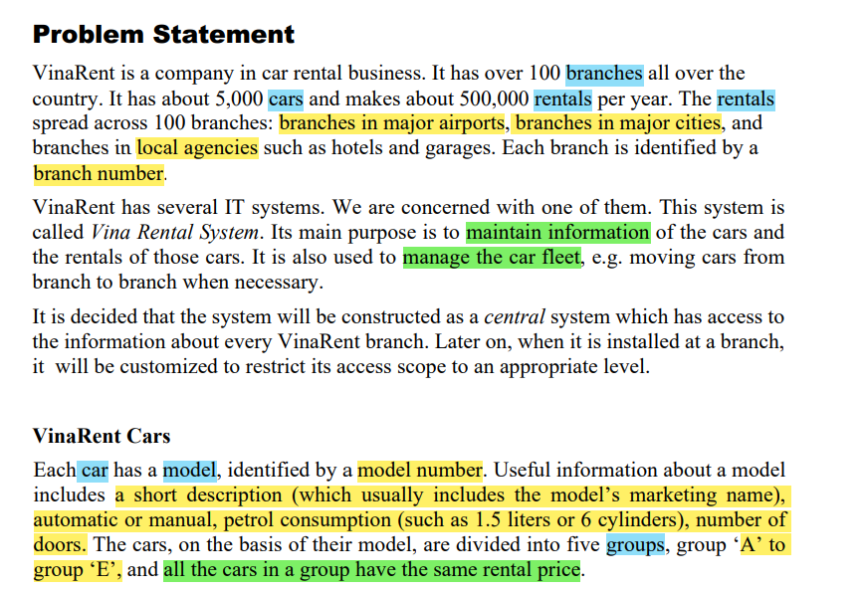

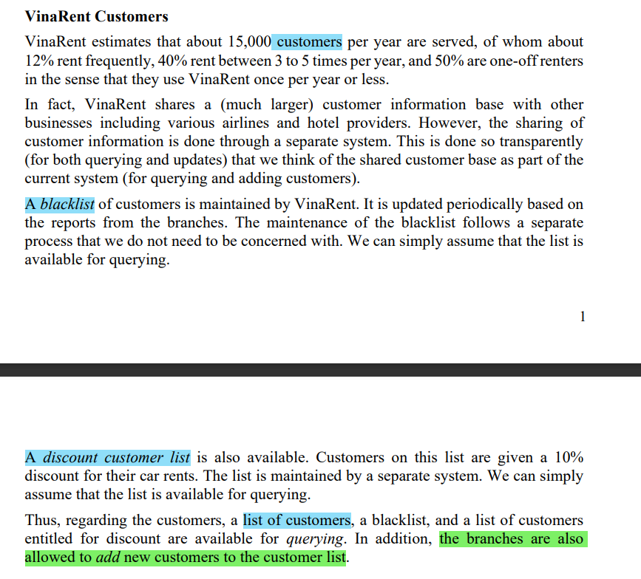

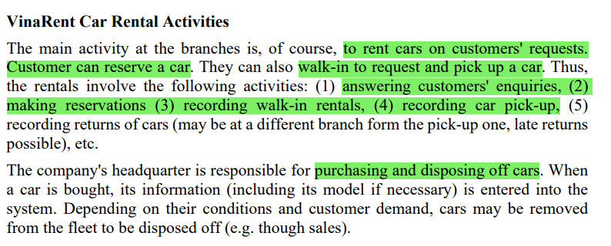

**⇒ Through above problem statement and business description analysis, we obtained:**

1. **Candidate classes:** Branch, Car, Rental, CModel, CGroup, Customer,Status,Payment,DepositPayment.  
   ( Potential Nouns: branch, car, rental, model, group, customer, blacklist, discount list)

*Step 2: identify classes*

**Classes:** Branch, Car, Rental, CModel, CGroup, Customer, RentalStatus, CarStatus, Payment, DepositPayment.

*Step 3: Identify multiplicities*

1. **Branch - Car: 1 - N**   
   A branch can have lots of car
2. **Branch - Customer: 1 - N**  
   A branch can have lots of customer
3. **Customer - Car: 1 - 1**  
   A customer can rent 1 car at a time
4. **Branch - Rental: 1 - N**  
   Branch can have and manage many rentals.
5. **Car - CModel: 1 - 1**  
   A car will have a fixed model
6. **Car - Group: 1 - 1**   
   1 Car model can only belong to 1 group.
7. **Rental - Payment: 1 - 1**

1 payment for 1 rental

*Step 4: Draw Analysis class diagram*

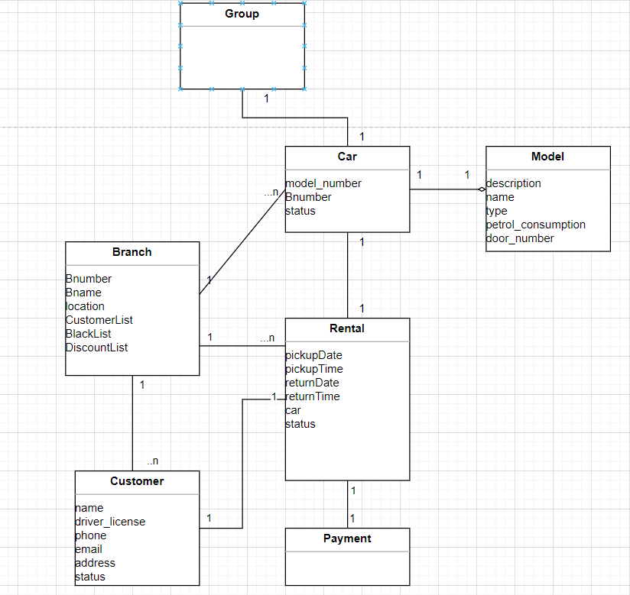

TASK 3:  
